HW 3

Kip Taylor

CCN

3/16/2021

1. Hammering distance = 2

1a. A valid character cannot be generated by making one change to any valid character, this is because of its parity bits. A valid character can be generated by making 2 changes to even bits or 2 changes to odd bits. Therefore, giving us 2 as the hammering distance.

1. Message given – 1101001100110101
2. The number of message bits = 16
3. Formula for finding is g^p greater than or equal to m+p+1 , p = # of parity bits , m = # of message bits
4. So we get 2^5 greater than or equal to 16 +5 +1 = 32 greater than or equal to 22 , this is true.
5. parity bits required = 5
6. 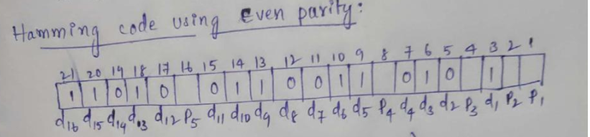
7. New message that is going to transmit after adding the parity bits is : **011010110011001110101 = answer**
8. Formula needed to determine the max utilization of the stop and wait protocol = utilization = 1/ 1+2a …. (1). A = bandwidth delay.
9. Formula for bandwidth delay = propagation delay / transmission delay
10. Formula for transmission time = number of frames / data rate.
11. First convert Kbps to bps: 4 kbps = 10 x 10^3 bps
12. Transmission time = L / 4x 10 ^3
13. Propagation delay = 20 x 10^-3 s
14. 80 / L
15. Then utilization = .5 = 1/ 1 + (160/L)
16. .5 = 80/L
17. L = 160
18. **So, 160 bits frame size requires there at least 50 percent of the efficiency using the stop and wait protocol**
19. **Answers below:**

* Given 4 data bits we need 3 parity bits.
* p1 = d1 + d2 + d4  
  p2 = d1 + d4 + d3  
  p3 = d2 + d4 + d3
* + is XOR operation here.
* The transmitted string will be d1d2d3d4p1p2p3.
* So, the three parity bits will be.
* p1 = 1 + 1 + 1 = 1  
  p2 = 1 + 1 + 1 = 1  
  p3 = 1 + 1 + 1 = 1
* transmitted data will be all 1’s: 11111111.

b)

**I :**  **p1 gets flipped so the received data will be 1111011. Check parities.**

**p1 = 1 + 1 + 1 = 1 (but p1 is 0 here)**

**p2 = 1 + 1 + 1 = 1**

**p3 = 1 + 1 + 1 = 1**

**error is then detected correctly.**

II)  **If it would have been an error in one of the data bits then it would have been reflected in two or more parity checks but there is an error in only one calculation, which means the parity bit p1 was flipped. So, to correct it we can simply flip the parity bit again**. It does not matter because we have correctly received all the data bits.

1. answer below:

part 1 :

1. . Same formula used in 3.
2. Channel utilization = 1/ 1+2a
3. Propagation delay = distance / propagation speed
4. 9 x 10^10 m / 3 x 10^8 m/s
5. 300s
6. Transmission time = # of frames / data rate
7. 32 x 8 = 256 kbps
8. 256 x 10^3 bits / 64 x 10^6 bps
9. 4/ 10^3 per second
10. 4x10^-3 s **=** 0.004s
11. 300s / 0.004s = 75000
12. 1/1+2(75000)
13. 1/150001
14. **6.666 x 10^-4 % = utilization using stop and wait protocol.**
15. **6 / 10^-6 ( this is what I got , the above answer is what the book says is right , but there is a discrepancy with the math, and my answer is mathematically correct. I do not know which one you want.)**

Part 2 :

1. Using above stuff
2. Channel utilization = 2/ 1+2a
3. A = bandwidth size, w = window size
4. Same bandwidth delay formula
5. Propagation delay = 9x10^10 m / 3x10^8 m/s
6. 300s
7. Transmission time same formula
8. 32 x 8 = 256 kbits
9. Trans time = 256 / 64
10. 4x10^-3 s
11. .004s
12. 300 / .004 = 750000
13. Channel utilization
14. 100% = 2/ 1+2(75000)
15. w/ 1+ 150000
16. w = 150001
17. **100 percent of link utilization window size using the sliding window protocol is w = 150001**

**If any extra examples or work is needed please reach out, to save pages of notes I excluded some work.**